Assignment on Linux

1. Practice all the below mentioned commands with all possible options:
cd, cat, ls, mkdir, rmdir, pwd, mv, cp
Ans.
* cd- The cd command is used to change the current directory (i.e., the directory in which the user is currently working).
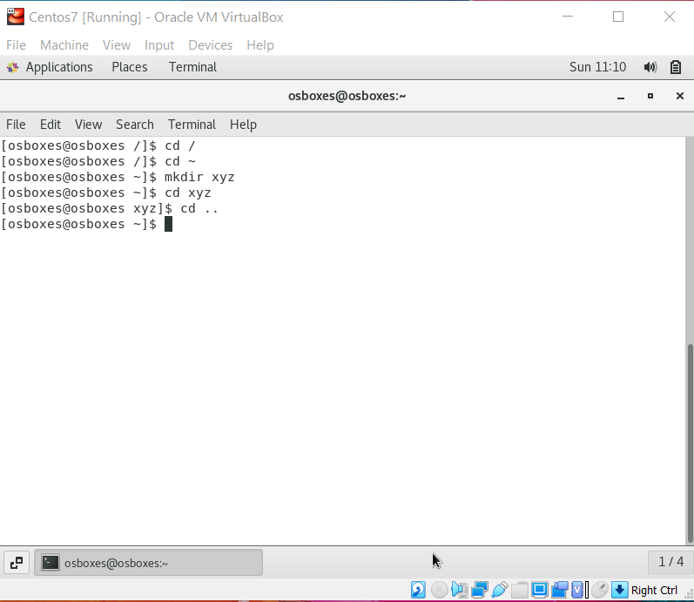
*cat-It reads data from the file and gives their content as output. It helps us to create, view, concatenate files.
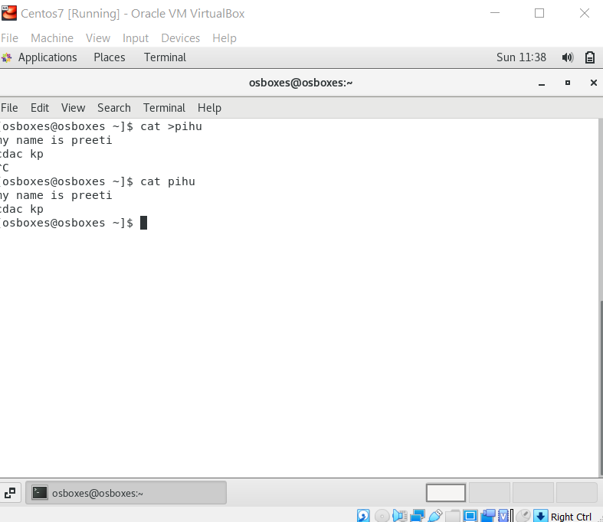
*ls-The ls command is a command-line utility for listing the contents
of a directory or directories given to it via standard input.
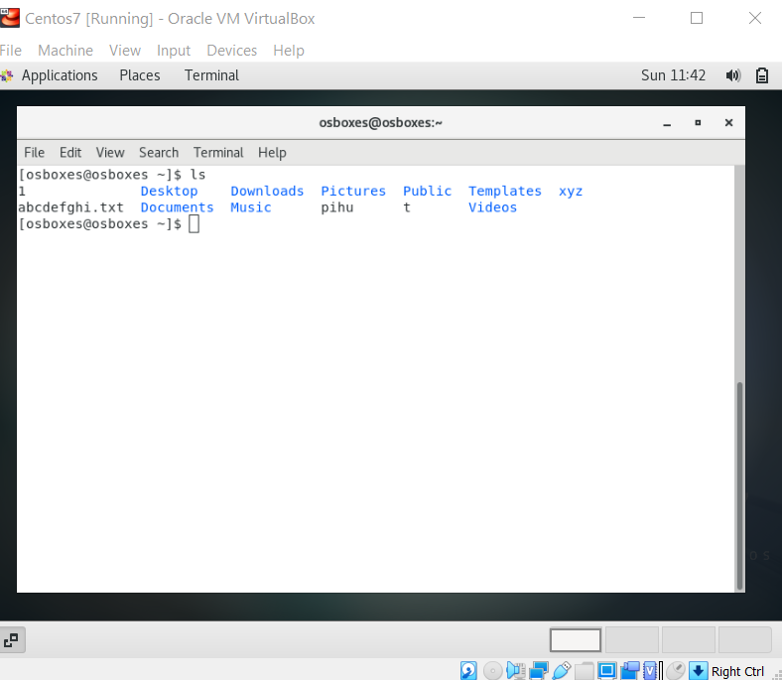
*mkdir- mkdir command in Linux allows the user to create directories .
*pwd- pwd' prints the current working directory or simply the directory user is, at present. It prints the current directory name with the complete path starting from root (/).
mv-mv us used to move files and directories.
cp- p stands for copy. This command is used to copy files or group of files or directory. It creates an exact image of a file on a disk with different file name. cp command require at least two filenames in its arguments.

2. Create a file without using the vi or any of the GUI editors?
Ans: we can create file using touch command
#touch file1
by using this we can create a file and after creating this file we can view it using ls command.
3.What does cd do when used without arguments?
Ans: Ans: when we run command cd without any arguments it takes us back to the home directory .
[root @osboxes practice] # cd
[root @osboxes practice ~ ] # pwd
/rootcd..
[root @osboxes practice] # cd
[root @osboxes practice ~ ] # pwd
/root
[root @osboxes ~ ] #
4. Move all the files from foo directory to bar directory.
NOTE: Make a directory foo with two empty files first.txt and second.txt
Make another directory bar now move all files from foo to bar.
Ans: #mkdir foo //making directory called foo
# cd foo
/foo # touch first.txt second.txt //creating file called first.txt and second.txt
/foo # cd ..
#mkdir bar //making directory called bar
#mv first.txt bar/ //moving first.txt and second.txt in bar directory
#mv second.txt bar/
here, we are using mkdir to make directory called foo and bar and touch is used to create a txt file in the foo directory later on by move command we will move the first.txt and second.txt to the bar directory.
5. Execute the two commands echo * and ls. What do you think echo did?
Ans:
[root@osboxes cdac] # echo * //printing the list of names of file in the directory
Echo command is used in scripting language and batch files to display a line of text/string on standard output or a file
[root@osboxes cdac] # ls
Abc xyz mnop boot home
It shows list of files present in the directory

6. Practice the below mentioned commands with all possible options:
chmod, find, head, more, tail & chgrp
Ans: *chmod – Used to change the access mode of a file.
Syntax:- chmod [reference] [operator] [mode] file…

* find - Used to find files and directories and perform subsequent operations on them.
Syntax:- find [-H] [-L ] [-P] [-D debugopts] [-O level] [path…] [expression]
* head - Prints the top N number of data of the given input.
Syntax:- head <file name>

* more - Used to view the text files in the command prompt, displaying one screen at a time in case the file is large (For example log files).
Syntax:- more <file name>

* tail - Prints the last N number of data of the given input.
Syntax:- tail [OPTION]…[FILE]…
* chgrp - used to change the group ownership of a file or directory. You can set the owner by using “chown” command, and the group by the “chgrp” command.
Syntax:- chgrp [OPTION]… GROUP FILE… chgrp [OPTION]… –reference=RFILE FILE…

7.Set the permissions of first.txt file to have all permissions for yourself?
Ans: chmod 777 first.txt
- Find out the location of the command 'service' using the suitable Linux command?
Ans: The service command is used to run a System V init script. Usually all system V init scripts are stored in /etc/init.d directory and service command can be used to start, stop, and restart the daemons and other services under Linux. All scripts in /etc/init.d accepts and supports at least the start, stop, and restart commands.
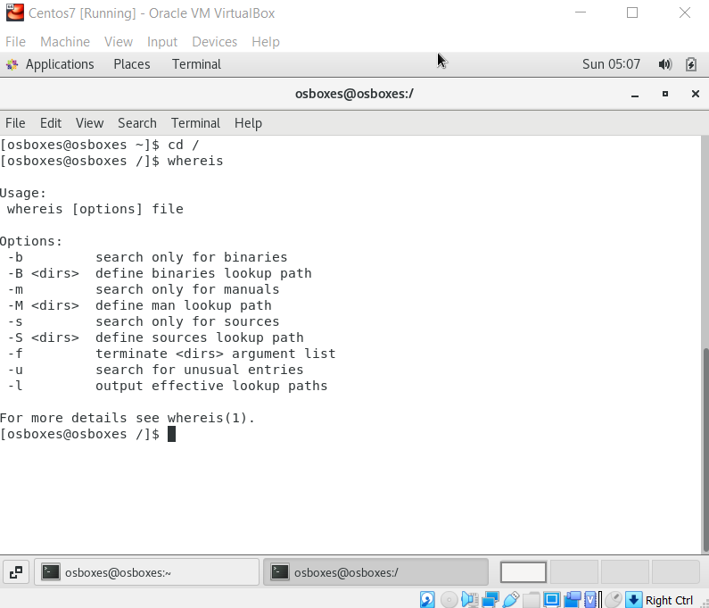

9. Create 3 files (file1 , file2, file3) & assign permissions:
– r, w to owner, group, and others for file1
- r, w to owner and group, r to others for file2
- r,x to owner, r to group, none to others for file3
Ans: r, w to owner, group, and others for file1
[root@osboxes Desktop] $ chmod ugo+rw file 1.txt
[root@osboxes Desktop] $ ls-lrt file 1.txt
-rw-rw-rw-1 osboxes osboxes 288 oct 9 8:14 file1.txt
It provides read and write permission for file1.txt to owner,group and other users
[root@osboxes Desktop]# touch file1.txt
[root@osboxes Desktop]# chmod ugo+rw file1.txt
[root@osboxes Desktop]# ls -lrt file1.txt
-rw-rw-rw-1 root root 0 oct 13 08:58 file1.txt
[root@osboxes Desktop]#
r, w to owner and group, r to others for file2
[root@osboxes Desktop] $ chmod ugo+rw file 2.txt
[root@osboxes Desktop] $ chmod o+r file 2.txt
[root@osboxes Desktop] $ ls-lrt file 2.txt
-rw-rw-rw-1 osboxes osboxes 288 oct 9 8:14 file1.txt
It provides read and write permission for file1.txt to owner,group and other users
[root@osboxes Desktop]# touch file2.txt
[root@osboxes Desktop]# chmod ug+rw file2.txt
[root@osboxes Desktop]# chmod o+r file2.txt
[root@osboxes Desktop]# ls -lrt file2.txt
-rw-rw-rw---1 root root 0 oct 13 08:59 file2.txt
[root@osboxes Desktop]#
- r,x to owner, r to group, none to others for file3
[root@osboxes Desktop] $ chmod o+rwx file 3.txt
[root@osboxes Desktop] $ ls-lrt file 3.txt
-r-x—r------1 osboxes osboxes 288 oct 9 8:14 file1.txt
//read excute permission to owner ,read permission for group and none of the permission to the other users for file1.txt
[root@osboxes Desktop]# touch file3.txt
[root@osboxes Desktop]# chmod u+w file3.txt
[root@osboxes Desktop]# chmod g+r file3.txt
[root@osboxes Desktop]# chmod o-rwx file3.txt
[root@osboxes Desktop]# ls -lrt file3.txt
-rw-rw-rw-1 root root 0 oct 13 09:00 file3.txt
[root@osboxes Desktop]#

10.Create a symbolic link in your current directory called ‘symlink’ to file1 created in /tmp folder

Ans: Creating Symlink To a File
To create a symbolic link to a given file, open your terminal and type:
ln -s source_file symbolic_link

Copy
Replace source_file with the name of the existing file for which you want to create the symbolic link and symbolic_link with the name of the symbolic link.
The symbolic_link parameter is optional. If you do not specify the symbolic link, the ln command will create a new link in your current directory:
In the following example, we are creating a symbolic link named my_link.txt to a file named my_file.txt:
ln -s my_file.txt my_link.txt
To verify that the symlink was successfully created, use the ls command:
ls -l my_link.txt
The output will look something like this:
lrwxrwxrwx 1 linuxize users 4 Nov 2 23:03 my_link.txt -> my_file.txt

- See the difference between cd ~ and cd - and cd.?
Ans: [pre@pre Desktop] $ cd~
[pre@pre Desktop ~] $
//it changes the current directory to home directory
[pre@pre Desktop~] $ cd-
/home/precd/Desktop
[pre@pre Desktop] $
//it takes us to the directory through which we just return back.
[pre@pre Desktop] $
//it takes us to the previous directory
- Use the cd command to go to the “root” of the file system?
Ans: This command is used to move to the parent directory of current directory, or the directory one level up from the current directory. “..” represents parent directory
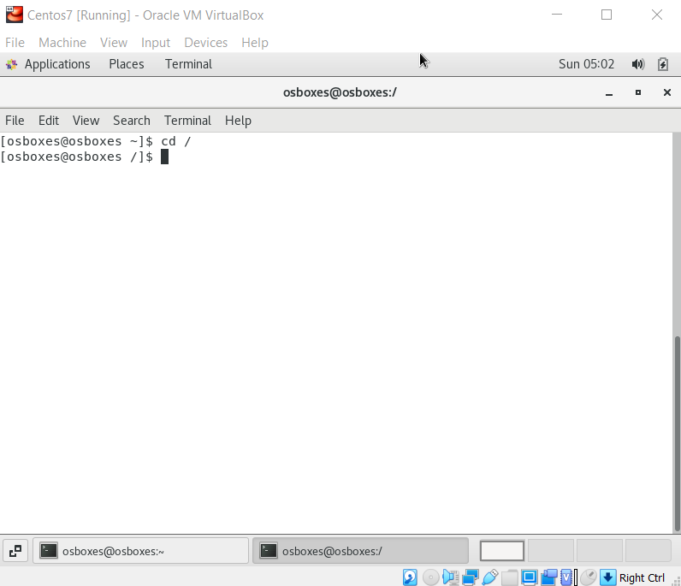

13.Explore the command chown using man pages.
Ans:man chown command : Linux chown command is used to change a file's ownership, directory, or symbolic link for a user or group.
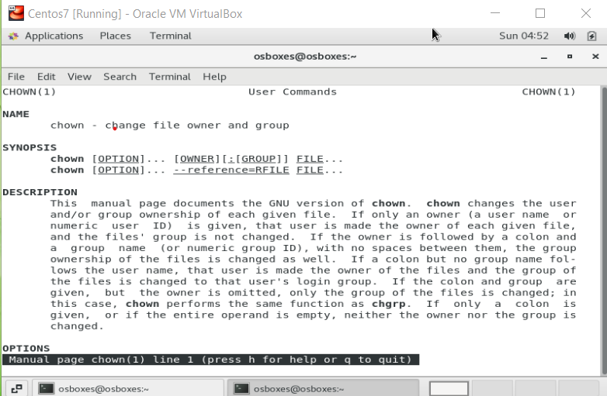

- Find out how you can see what a system is running and what resources the system is using commands ps and top?
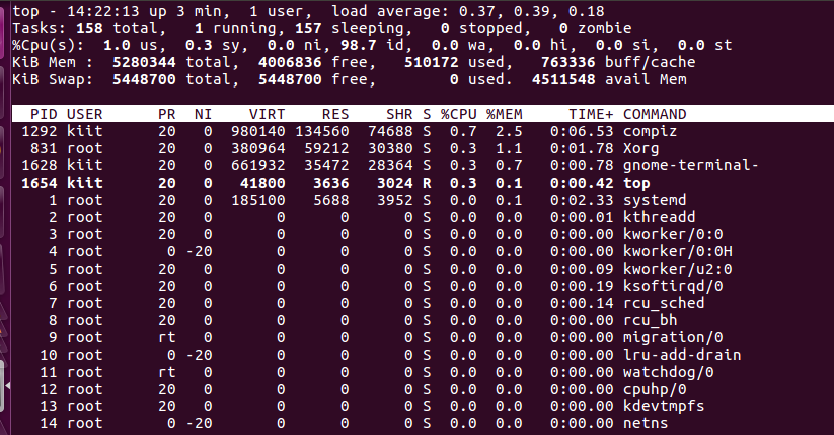

15.Find out the location of the command 'service' using the suitable Linux command?
Ans: 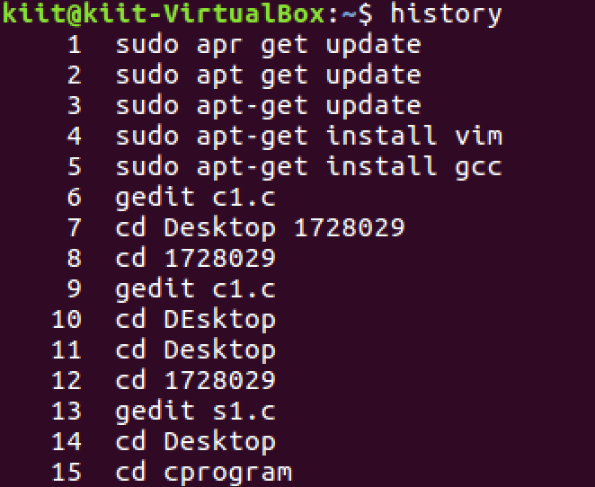
- Observe how the command completion happens on tab?
Ans: BEFORE
[pre@pre Desktop]$ ls
[pre@pre Desktop]$ vi t
AFTER
[pre@pre Desktop]$ ls
[pre@pre Desktop]$ vi testsam.sh

17. Run a Linux command to display the list of users who are currently using the Linux machine.
Ans:
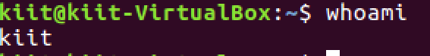

18. What is the Linux command to display calendar for the October month 2020.
Ans.
pre@pre-VirtualBox: ~/Desktop $ cal
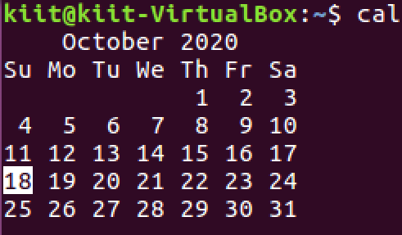

19. Delete an empty directory and verify your results by using the ls command. Try deleting a directory which is not empty and record the error message.
Ans: rmdir is used to delete the directories
eg: #mkdir m
# cd m
/m # touch n.txt
/m # cd ..
# rmdir m

ERROR: remdir: failed to remove 'h' : Directory not empty
20. Which command is used to display the operating system name?
Ans: uname command is used to display the operating system name.
$ uname
